## horizontal line



PHP PROJECT DEVELOPER GUIDE

Online Movie System

**(Batch: 2112F1)**

20.11.2022

**─**

**PROJECT** **SUBMITTED BY**

|  |  |
| --- | --- |
| Student1350700 | FAIZ ULLAH KHAN |
| Student1333306 | AMAN ULLAH |
| Student1351064 | MUHAMMAD ISMAIL |
| Student1350716 | SITARA EIJAZ |

**Project Instructor Miss** **Hafsa khan**

**Batch Code 2112F1**

# 

SCREEN SHOTS OF SOURCE CODE OF

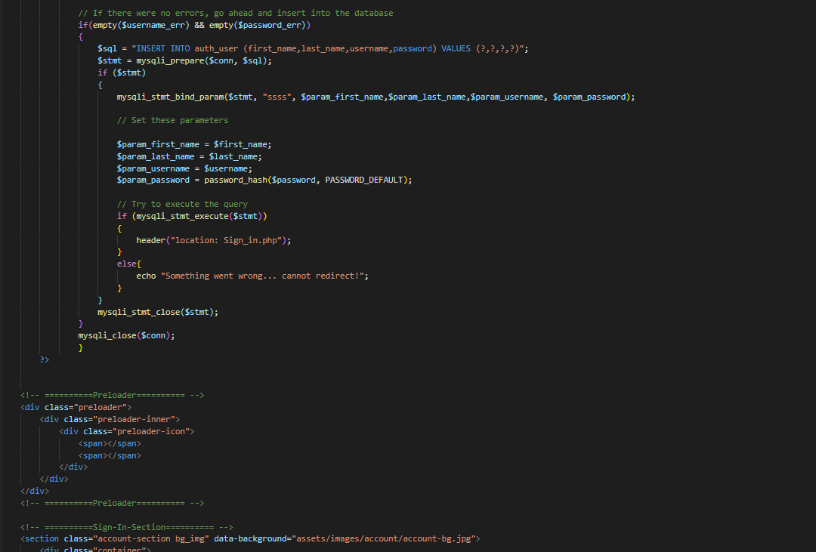Online Movie Booking system

# Home Page:

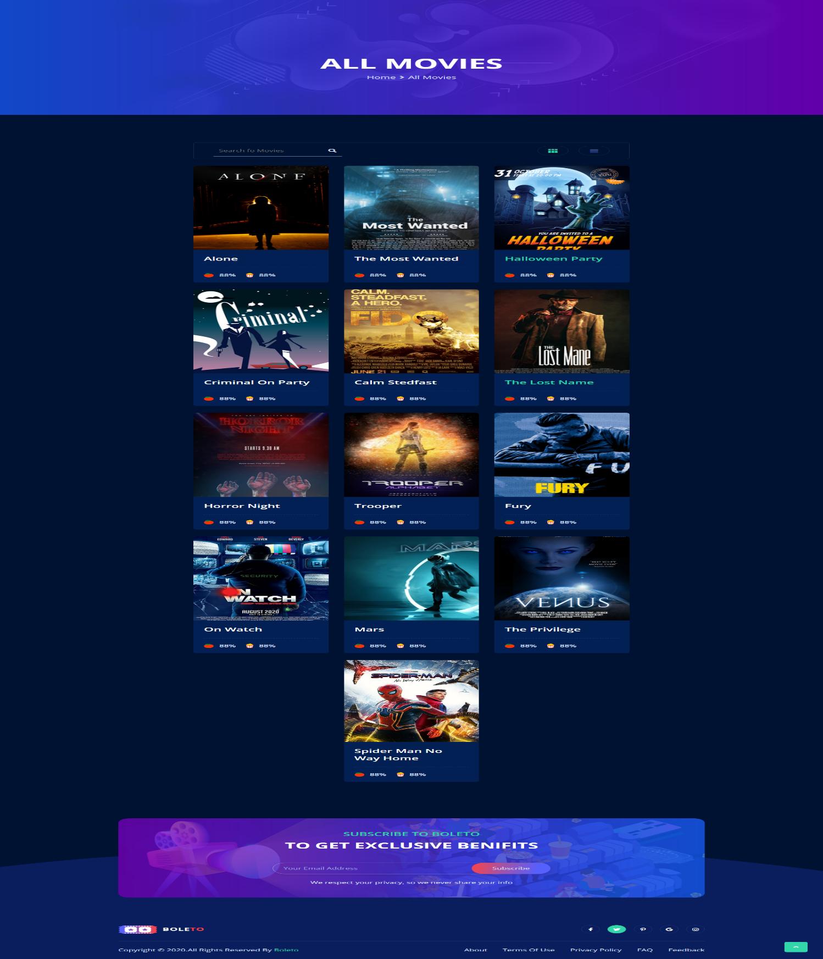

# About Us Page:

# Contact Us Page:

**Admin Panel :**

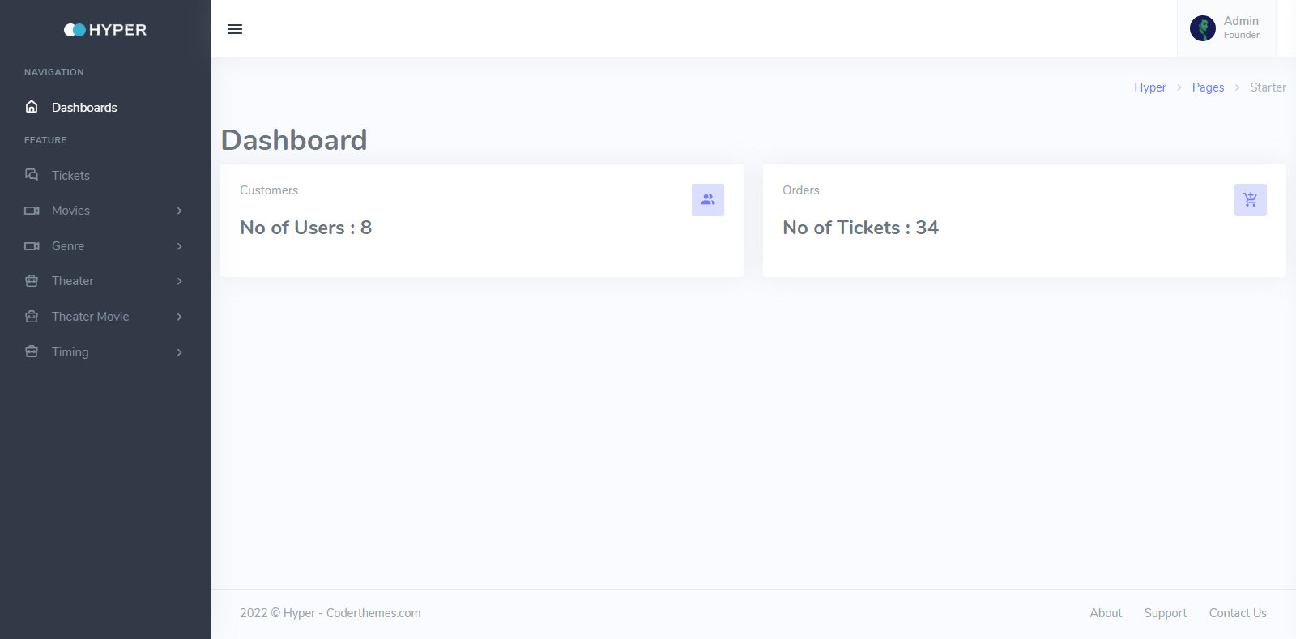

# Signup Page:



# Login Page:

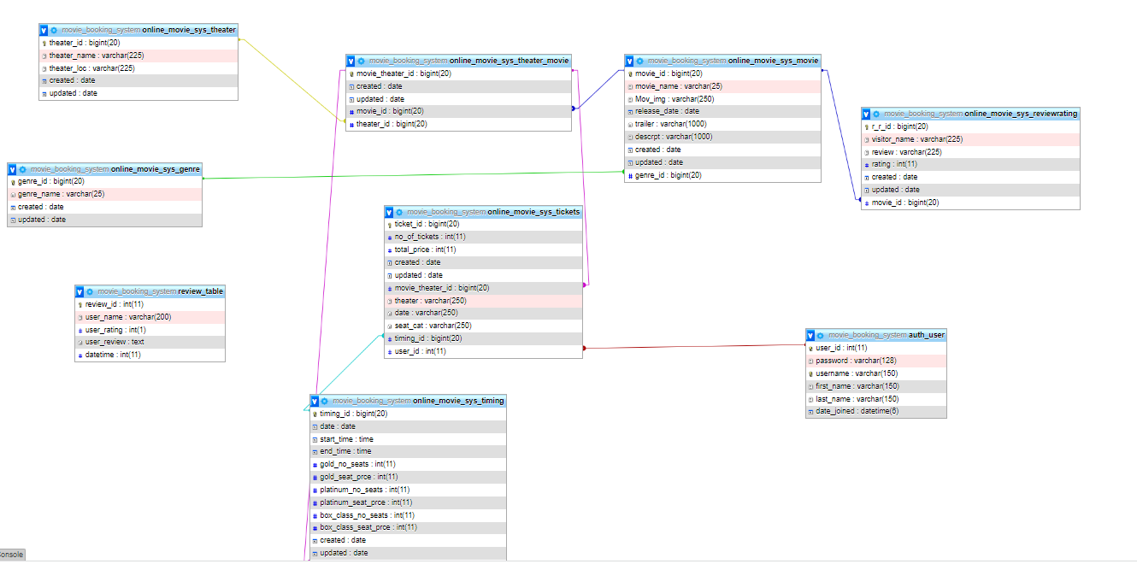Database of PHP Project:

# THE END ….